Linux System and Its Application



Student ID: | 312023704026
Name: | Adam baha
Date:

Lab1 Linux Graphical Interface
- Objective
- Be familiar with Desktop environment
- Understand system structure of Linux
- Understand system configuration under Desktop environment
- Lab Environment
- Recommended: Ubuntu Desktop 24.04
- The other Linux or Unix-like environment
- Instructions
- Write answers to the questions related to each task right below the question.
- Use screenshots to show that you finish a specific task by paste it right below the tasks and describe the screenshots.
- When you finish, you need to rename the file name "Linux2026_lab1_STUID.docx" (STUID should be changed to your own student id) and then upload it to the Chaoxing system before 15th March.
- Tasks
- Install Ubuntu Desktop OS with virtual machine software on your own PC or Mac. Try to create an account with your name. After installation please login with the created account. Go to "Settings" to find the page related to user account and take a screenshot (in the "System" tab you can find "Users").
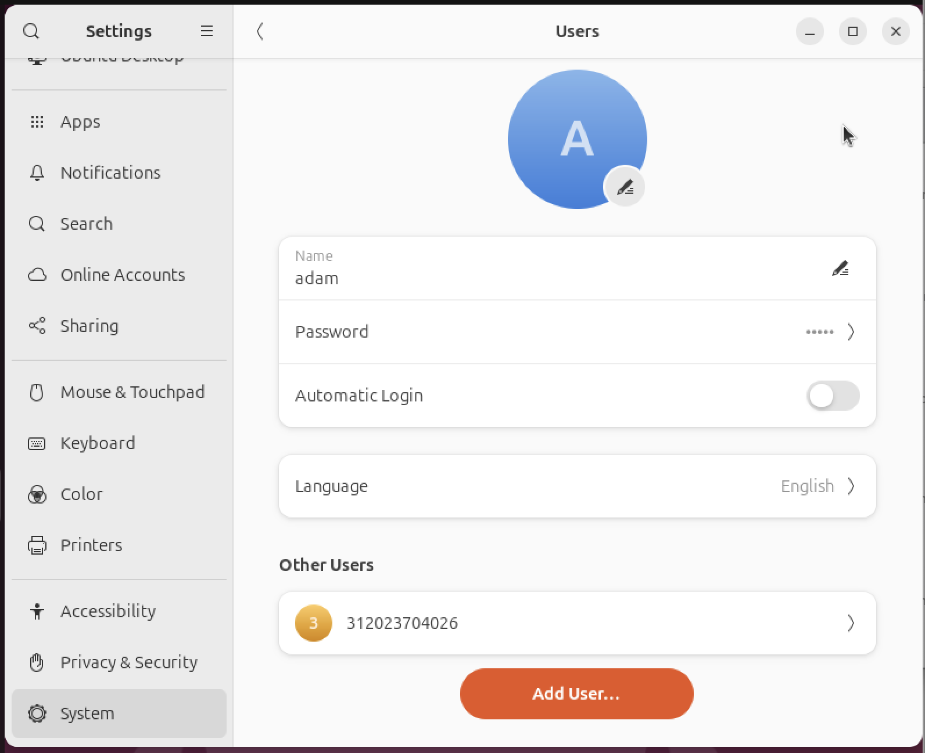
This ubuntu distribution doesn’t Allow me to use numbers as a username,
So i used sudo adduser --force-badname 312023704026, but the problem persisted
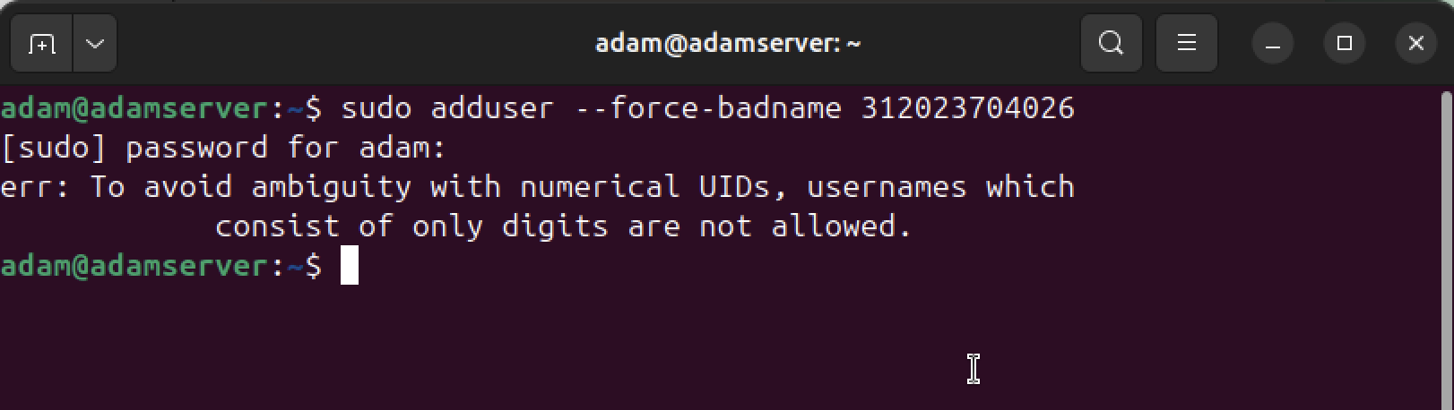
- Use the graphical interface to add a new user and set the account name to your student ID. (IMPORTANT!! This account will be used in the other labs as well). Switch the user to the new created one (your student id), then try to finish the following tasks.
  - Modify the display setting, and try to adjust the resolution till you feel comfortable.

  - Download a wallpaper by using the browser, and change the Desktop background to the wallpaper you downloaded.
  - Press the "Prt SC" key on the keyboard and your will find you can capture screenshots inside the Linux system. (But the screenshots are in the Linux system, how to transfer them to your host system? Or you can just edit this file with "LibreOffice" under Linux)
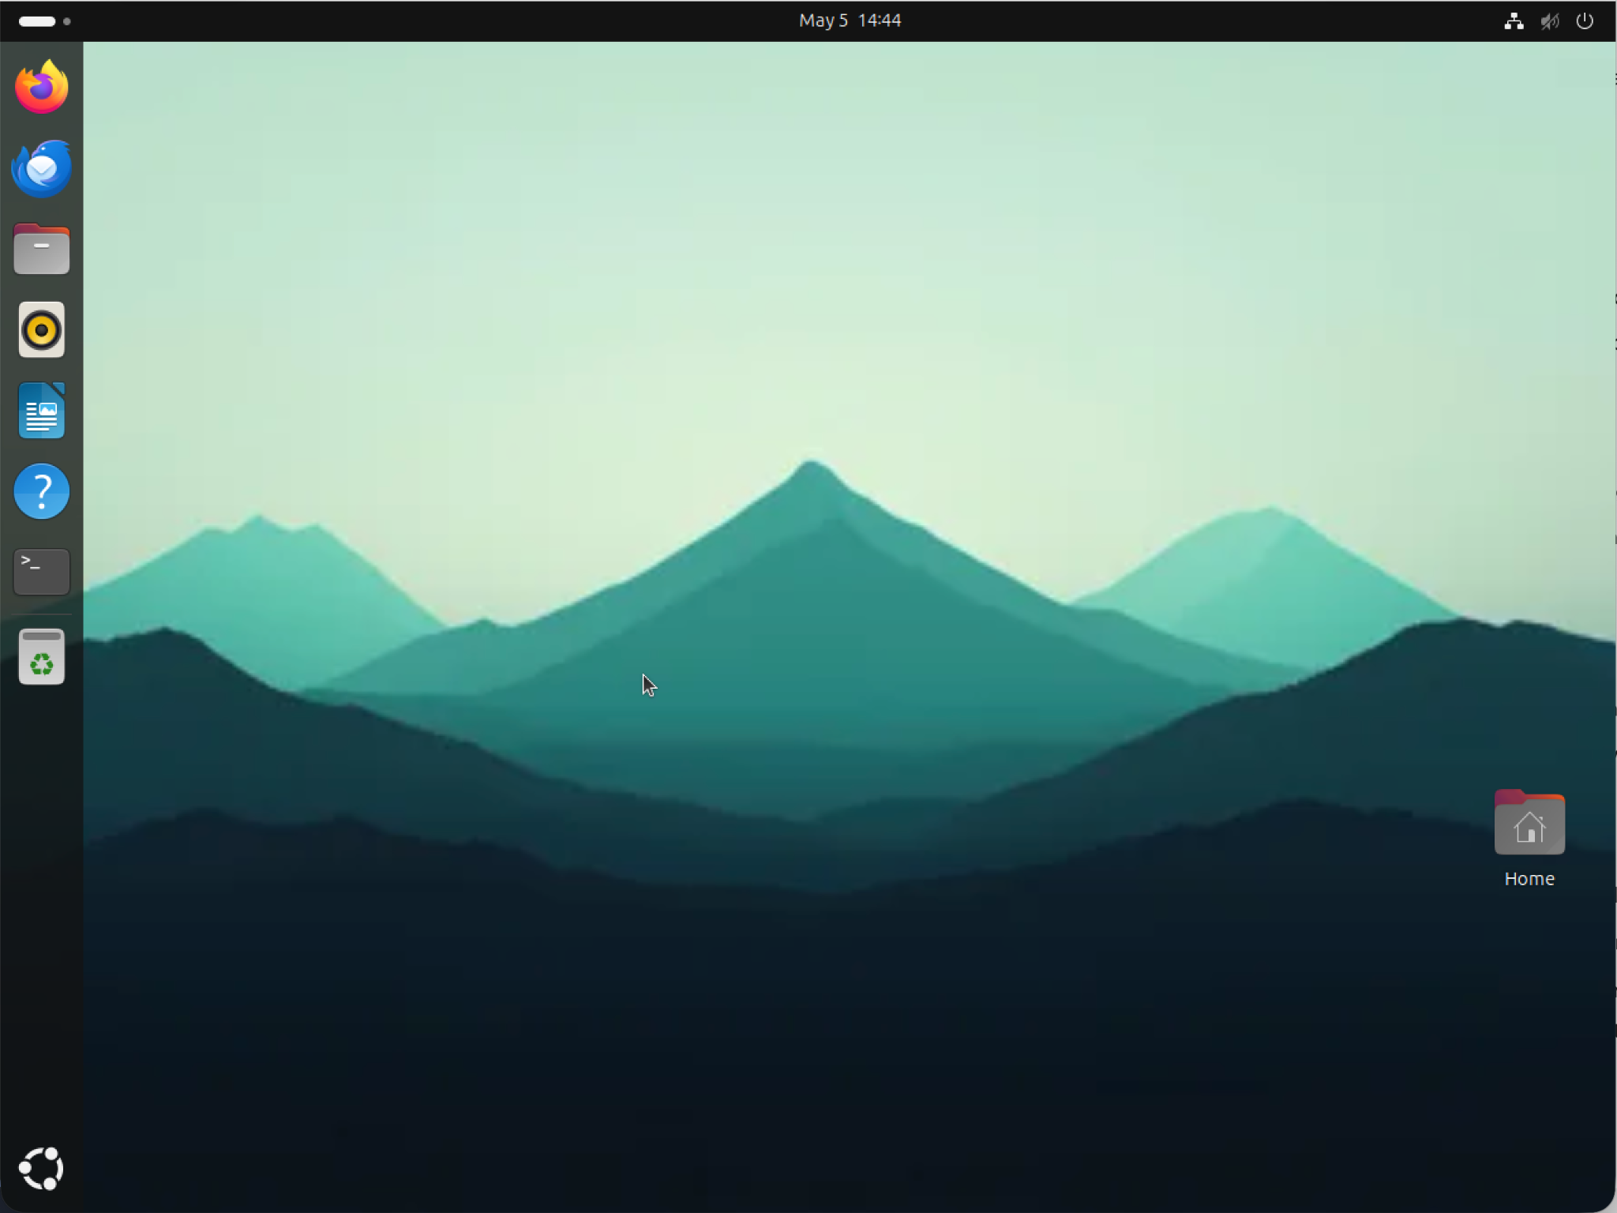
  - Find a program named "terminal" and pin it on the sidebar. (Once you open a program, it will show an icon on the sidebar, right click on it you can click "Pin to Dash" to pin it on the sidebar)
  - Open "terminal", use "uname -a" and "lsb_release -a" to check the kernel version and system information of the installed system.
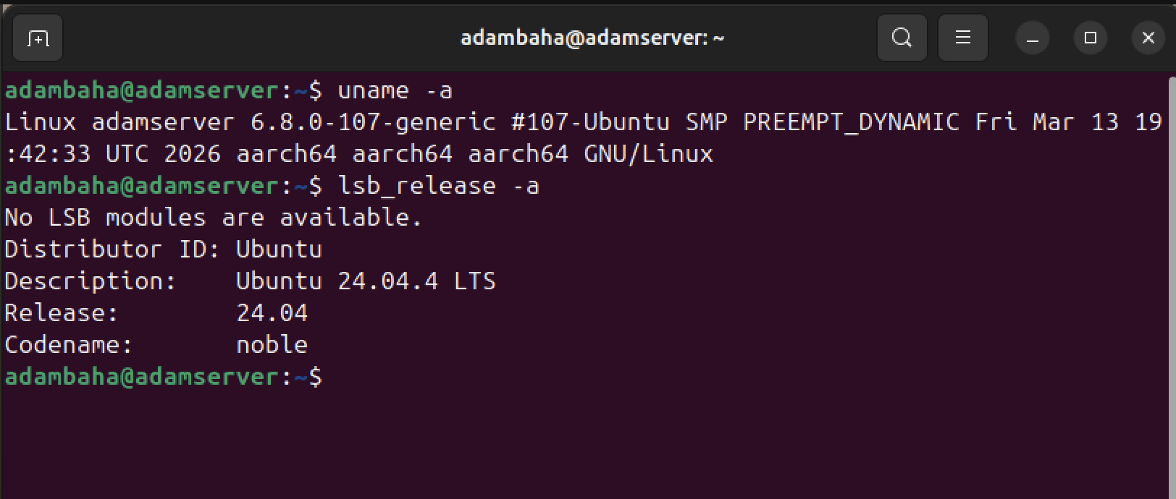
  - You should fine a folder named "Home" on the Desktop. Open it and what will you see? Click "Other Locations" on the left side and you will find a disk icon with the computer name you set, go inside and you will find a folder named "home", what do you see inside of this "home" folder? Try to think about what is the differences between the "Home" and "home" folders.
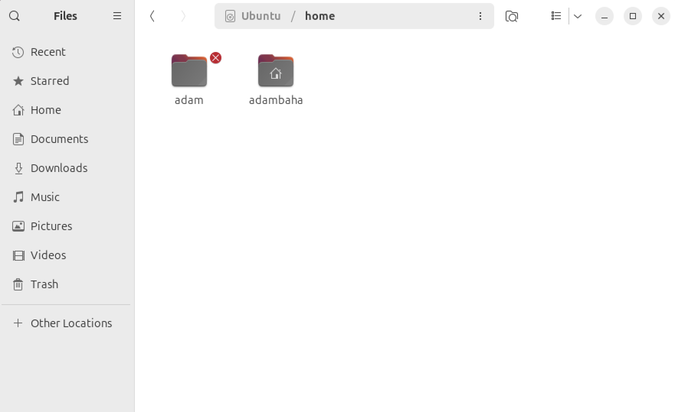

- Home (Upper case): This is a shortcut to the current logged-in user's private directory (also known as ~). It only contains your specific files.
- home (Lower case): This is a system-level directory (/home) that acts as a container for all user accounts on the Linux machine.

